Middleton Stoney Harvest Supper

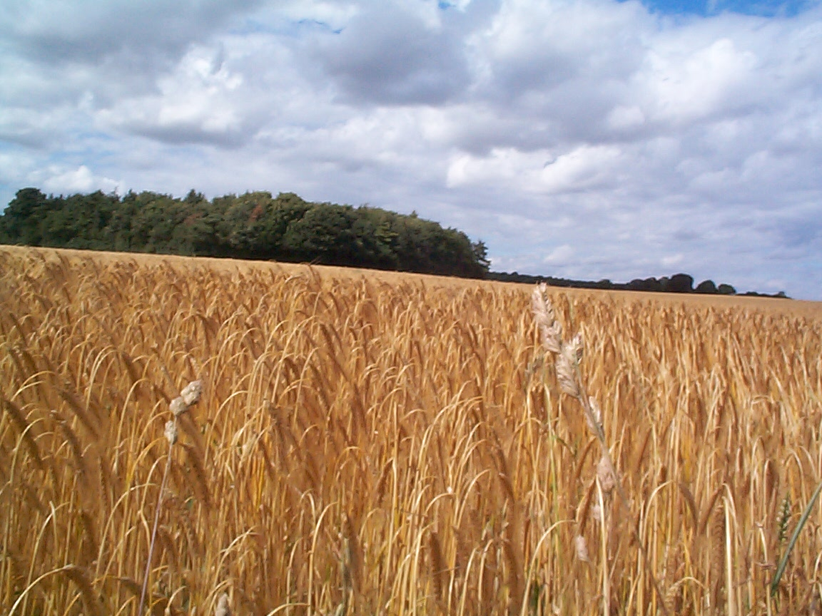

Friday 4th October 2019
in
The Village Hall at 7.30pm
Tickets £8.00

Tickets from:
Jen Hudson (343225),
Jennifer Hughes (343471), Jane Brown (343591)
(Cash or cheque with booking – cheques payable to Middleton Stoney Parish Church)

Please respond by Friday 27 September

(Please bring drinks, plates, glasses & cutlery)

Donations: Raffle Prizes and Jam & Preserves (to sell on the evening) welcomed.
Proceeds to All Saints Parish Church

